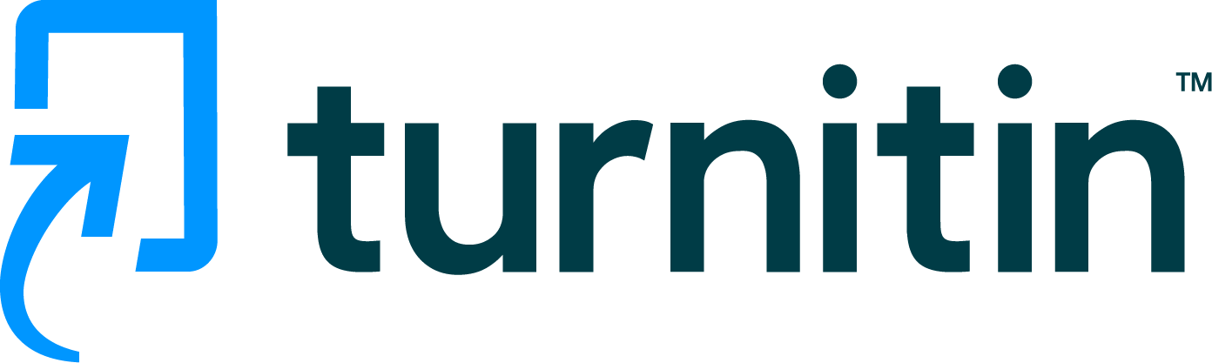
Page 1 of 14 - Cover Page Submission ID trn:oid:::3618:89237131

Kishore K

RE-2022-520872
 United International University

Document Details

Submission ID trn:oid:::3618:89237131

11 Pages

7,416 Words

37,552 Characters
Submission Date
Apr 2, 2025, 5:24 PM GMT+5:30

Download Date
Apr 2, 2025, 5:26 PM GMT+5:30

File Name
RE-2022-520872.pdf

File Size
1.6 MB


Page 1 of 14 - Cover Page Submission ID trn:oid:::3618:89237131


Page 2 of 14 - Integrity Overview Submission ID trn:oid:::3618:89237131

19% Overall Similarity
The combined total of all matches, including overlapping sources, for each database.

Filtered from the Report
Bibliography Quoted Text

Match Groups
 33 Not Cited or Quoted 19%
Matches with neither in-text citation nor quotation marks

0 Missing Quotations 0%
Matches that are still very similar to source material

0 Missing Citation 0%
Matches that have quotation marks, but no in-text citation


0 Cited and Quoted 0%
Matches with in-text citation present, but no quotation marks
Top Sources

1% |   Internet sources
1% |   Publications
19% |   Submitted works (Student Papers)

Integrity Flags
0 Integrity Flags for Review

Our system's algorithms look deeply at a document for any inconsistencies that would set it apart from a normal submission. If we notice something strange, we flag it for you to review.

A Flag is not necessarily an indicator of a problem. However, we'd recommend you focus your attention there for further review.
No suspicious text manipulations found.


Page 2 of 14 - Integrity Overview Submission ID trn:oid:::3618:89237131



Match Groups
Page 3 of 14 - Integrity Overview Submission ID trn:oid:::3618:89237131

Top Sources



33 Not Cited or Quoted 99%
1% | Internet sources
19% | Publications
1% | Submitted works (Student Papers)


Matches with neither in-text citation nor quotation marks


0 Missing Quotations 0%
Matches that are still very similar to source material

0 Missing Citation 0%
Matches that have quotation marks, but no in-text citation


0 Cited and Quoted 0%
Matches with in-text citation present, but no quotation marks

Top Sources
The sources with the highest number of matches within the submission. Overlapping sources will not be displayed.
1
Submitted works
University of Houston Clear Lake on 2024-04-17 1
2
Publication

Muhammad Shoaib Farooq, Usman Iftikhar, Adel Khelifi. "A Framework to Make V… 1%
3
Publication

Muhammad Shoaib Farooq, Usman Iftikhar, Adel Khelifi. "A Framework to make … 4%
4
Internet

ijarsct.co.in 2%
5
Submitted works

Panimalar Engineering College on 2025-03-15 <1%


Page 3 of 14 - Integrity Overview Submission ID trn:oid:::3618:89237131

FRAME WORK OF ONLINE VOTING SYSTEM WITH
Page 4 of 14 - Integrity Submission Submission ID trn:oid:::3618:89237131
FACE RECOGANATION USING BLOCK CHAIN

Mrs Prabha A Assistant professor
Department of Computer Science and
Engineering
5
5

India pecleela2005@
Panimalar Engineering College
Chennai,
gmail.com

Vijaymaharajs Student
Department of Computer Science and
Engineering

India vijaymaharaj03vj@gmail.com
Panimalar Engineering College
Chennai,
Lalith kumar P

India lalalith286kumar@
Student
Department of Computer Science and
Engineering
Panimalar Engineering College
Chennai,
gmail.com

Pradeep C
Student
Department of Computer Science and
Engineering

India cpradeep3057@gmail.com
Blockchain Finally, the performance evaluation of the
Abstract- A widespread mistrust towards the traditional
Panimalar Engineering College
Chennai,



during the process of voting has been elaborated using
traditional voting system can be given to the miners [6]. It
does not require a physical module/voting machine which


4

INDEX TERMS :
reason behind the failure of the traditional and current
digital voting system is that it can be easily exploited. The
primary objective is to resolve problems of the traditional
and digital voting system, which include any kind of
mishap or injustice during the process of voting.
Blockchain technology can be used in the voting system to
have a fair election and reduce injustice. The physical
voting systems have many flaws in it as well as the digital
voting systems are not perfect enough to be implemented
proposed system shows that the system can be
implemented in a large-scale population.
E-polling, voting system, blockchain application,
blockchain voting, E-voting, electoral system, blockchain,
cryptographic hash, secure voting
I. Introduction
Blockchain can reduce a lot of efforts and resources
invested in polling stations, specifying the areas,
appointing staff, and preventing security risks at polling
stations [1]. Holding a digital election through blockchain
not only saves money but also reduces the risk of inequity
in the voting process [2]. Modern technologies such as
blockchain technology are very secure and beneficial if
voting system has made democratic voting in any country
very critical. People have seen their fundamental rights
being violated. Other digital voting systems have been
challenged due to a lack of transparency. Most voting
systems are not transparent enough; this makes it very

3

man-ner,
on large scale. This appraises the need for solution to
secure the democratic rights of the people. This article
presents a platform based on modern technology
blockchain that provides maximum transparency and
reliability of the system to build a trustful relationship
between voters and election authorities. The proposed
platform provides a framework that can be implemented
to conduct voting activity digitally through blockchain
without involving any physical polling stations. Our
proposed framework supports a scalable blockchain, by
using flexible consensus algorithms. The Chain Security
algorithm applied in the voting system makes the voting
transaction more secure. Smart contracts provide a secure
connection between the user and the network while
executing a transaction in the chain. The security of the
blockchain based voting system has also been discussed.
Additionally, encryption of transactions using
cryptographic hash and prevention of attack 51% on the
blockchain has also been elaborated. Furthermore, the
methodology for carrying out blockchain transactions
used carefully. It can make the voting system more
transparent, reliable, and also enhance traceability of
transactions [3]. In a traditional digital voting system, a
voting machine has been used which is connected to a
Centralized database. This machine can be tampered with
by a person who has physical access to it. It may cause
single point of failure in the whole network of the voting
system; on the other hand, an immutable blockchain would
not be affected by an individual saboteur in the network [4].
In a blockchain, the data is being stored in a decentralized
which is constantly verified if the records are
accurate. Therefore, in case of a malicious attack on a node,
only that node would be affected and peer to peer network
still provide all services. It makes blockchain technology a
threat- proof and reliable system to be used as a private
ledger in the voting system. Blockchain has offered a level
of security and trust more than the previously used
technologies [5]. The resources can be saved by hiring less
staff, security forces, and arranging polling stations for a
Page 4 of 14 - Integrity Submission
Submission ID trn:oid:::3618:89237131

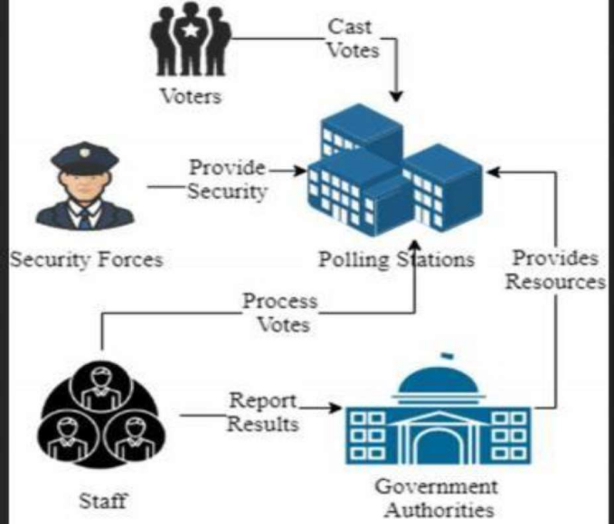



tempering and the casting of
ghost votes. Each ID can be used to cast vote once.
By implementing the blockchain, the integrity of the votes
stored on the system gets secured. Blockchain blocks any
illegal breach to the system that tries to equip any role in the
chain. It eliminates the dependency on middlemen in the
vot-ing system which helps to save resources and prevent
human errors. Initially, the blockchain-based Voting
VMS) will be implemented along with
the manual traditional voting system, to ensure its validity.
When VMS will show promising results, then the whole
voting activity could be transferred to VMS only. A pilot
implementation can be carried out in small elections of an
area before large- scale implementation.
The rest of the article is structured as follows: the
related work has been presented in Section II, and the pro-
posed framework has been discussed in Section III, while
section IV focuses on the implementation and evaluation of
the proposed framework. Finally, the article has been con-
cluded in Section V.
II. RELATED WORK
G. Rathee et al. [14] introduced a digital voting system
based on blockchain that could be implemented in a
technologically advanced environment. The system
assumed that all the
external entities are
trustworthy. However, the security flaws in the system
could be a huge risk, as intruders can enter the system to
rig the votes. Whereas in our proposed voting system, the
use of encryption and secure networks minimize the risk of
intruders barging into the votes.
M. Pawlak et al. [15], proposed a system that does not
require any operating entities. However, it could not secure
In the traditional voting system, a voter first registers
his voting status by sending an SMS to Identification
Authorities (IA) [7]. IA verifies the voter and enlists his
vote in the specified polling station. The voter goes to the
polling station physically to cast the vote. Votes are then
collected by the appointed staff at polling stations [8].
Staff is responsible for counting the votes and reporting
them to higher authorities. This involvement of staff in the
voting system increases the chances of human errors [3].
The authorities again make sure that the count is correct
and then publish the result. This whole system has a lot of
loopholes where tampering with votes is possible [9].
Either the staff can tamper with the votes or add fake votes
while counting them. The authorities can announce wrong
results of their own choice, under the influence of a third
party [10]. There is no surety given to the voter that proves
that his vote is being considered or not. The whole
traditional voting system offers no transparency or
guarantee of fair voting. The situation cannot be resolved
by only digitalizing the system or by casting votes through
digital voting machines [11]. These digital voting
machines can be tampered with by hackers; which disrupts
the
process [12]. Hence, a decentralized system is
required which can keep the data secure, even if a single
node
The problems discussed above
highlight the lack of transparency in traditional and
digital voting systems [13]. The authorized organization
gets blamed frequently for any human error or lack of
system efficiency, even if they try to conduct fair voting
in-country [7]. The Fig. 1 shows the traditional voting
system implemented in most countries. The main focus of
this manuscript is to discourage any illegal tampering in
the voting system to gain the trust of voters by proposing
a
based voting system.
of the core
features of blockchain technology is that if a node is
added to the chain it can never be erased. It is possible
due to decentralized data storage in blockchain
technology. The data is stored on multiple nodes in the
chain and the data is copied on every single node of the
network, which makes it impossible to erase it from
every node simultaneously. It assures the reliability of the
voting system. Moreover,
The system was able to collect votes from users but due to
com-plex computation, upon higher user rate the latency
became an issue. The identities of the voters became
vulnerable. The system could not compute a large amount
of data hence it has failed to be implemented at a large
scale. Whereas in our proposed voting system the latency
is managed by flexible use of consensus algorithms. The
use of cryptographic hash in
omits the risk of
always has a Chance of cyber-attack through tampering
devices [1]. The most ambient part of this system is the
transparency which make people guarantee that their votes
are being used in the right means. Blockchain technology
is more secure and transparent than any other database. It
is being considered to be applied in critical systems like
banking, medical fields, food safety and cryptocurrency
exchange [6]. Therefore, using blockchain technology in
the voting system assures that it will be more trustable,
secure and consistent as compare to other digital voting
systems. Blockchain technology can carry out a
voting process while maintaining voter privacy and
trust.
computation is
reduced because the data is computed on the fly, every
node computes the data separately which is then stored as
one. Voter verification is made possible through online
verification with the assistance of Identifying authorities.
The concept of using blockchain in the voting system is
offered to eliminate
Submission ID trn:oid:::3618:89237131
ManagementSystem(
block chain
Submission ID trn:oid:::3618:89237131
trans-
parent
block-chain-
On
thevote
Page 5 of 14 - Integrity Submission
thetallying
Page 5 of 14 - Integrity Submission
2
voting
getsCorrupt.

connected



2
3


1

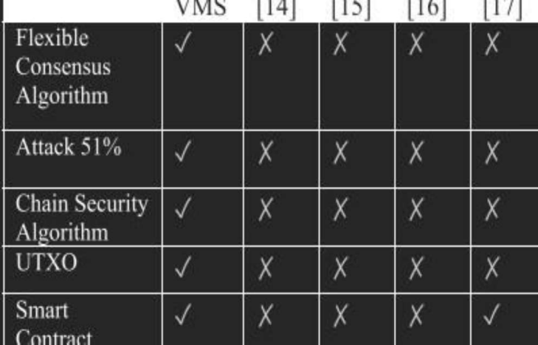





A proposed system by D.
al. [16] improved the
robustness and fair tallying of votes. End-to-end
was made possible for voters to assure their
count of the vote is integrated. Each voter was able to view
if his vote was considered and recorded correctly. The
voters were given a unique code that they could enter into
the system to verify their vote. Whereas in our proposed
voting system the verification of votes has been further
simplified. Voters can verify their votes through registered
phone numbers and Email addresses. Verification of votes
after the voting activity builds up the trust of voters.
The voting system without polling stations was
discussed by P. Mccorry et al. [17]. He suggested that
voting through the internet using blockchain can give good
results if
correctly. They discussed some
technical flaws in digital voting systems. The robustness
of the system could not be controlled. The error of
gets minimal by using end-to-end
verification. These voting systems had low latency and
did not secure the privacy of voters. This latency in the
system is controlled by using a flexible consensus
algorithm and smart contracts in the blockchain voting
system being proposed. The Table 1 shows a detailed
comparison of our proposed VMS with other voting
systems based on blockchain
The state-of-
the-art blockchain voting system was based on a
single fixed consensus algorithm however our
proposed system supports a flexible consensus
algorithm at run time that helps to control the
performance of the voting activity. We have also
proposed a solution for the prevention of the 51%
attack to prevent malicious activities during the voting
process. Our system has further proposed the Chain
security Algorithm which automatically verifies the
validity of the chain each time a new block is added to it
or some unauthorized change occurs in block data. We
have also pro- posed a mechanism of Unspent Transaction
Output(UTXO) and Smart Contracts that allow the system
to prevent any incomplete and malicious transaction in the
blockchain.
The above discussion shows that there has been a lot
of debate about making a secure, efficient, and transparent
system in past but any comprehensive solution or
system has not been proposed that could fulfill all
requirements and key purposes of the voting system. The
novelty of the
III. PROPOSED FRAMEWORK OF VOTING SYSTEM
Blockchain is mutable, unlike other programming
structures where an admin can add, delete or update the
data. If such a system is used for voting, then anyone
having access can tamper with the system and update or
delete the votes. This is not the case with blockchain
technology. Once a node is added to the chain, it cannot be
deleted or updated under any condition. If a node is
attacked by an intruder, the corresponding nodes detects it
and rebuild the damaged node, hence the chain becomes
immutable. The blockchain is decentralized which makes
the voting system independent of any single computing
node. The voting activity remains operational even if any
one or more nodes get attacked or become unavailable. It
assures reliability under any severe condition. The main
stakeholders of the proposed framework are voters,
Identification Authorities (IA), and
Authority (AA) of election commission.
A. VOTING SYSTEM ARCHITECTURE.
In Fig. 2 a high-level architecture of the proposed
system has been presented. It shows how the main
stakeholders; Voters, VMS, AA, and IA work together to
perform certain voting tasks. All voters are connected to
VMS directly through
it is either a mobile application
or a web portal. The identification authority verifies voters
registering in the
Any voter who is verified and
eligible to vote is allowed in the application to take part in
voting.
The process of the whole system includes certain parts;
the first one is the user interface of the application, which
also requires front-end security. It is critical because the
user enters his credentials on that interface, so it should be
secure
and simple. The system provides full and fair access
to every user during voting activity. It also provides
traceability after casting of vote. The voter registers in the
system by his
VMS uses the ID details of voters
proposed system besides implementing
blockchain is to assure security, transparency, and
integrity of results in a voting system that empowers the
trust of voters. This article proposes a more efficient and
better implementation of blockchain in digital as well as a
Submission ID trn:oid:::3618:89237131
Submission ID trn:oid:::3618:89237131
credentials.
system.
APP;
Administration
2
2
3
2
 |  |  |  |  |  | Chaumet

Page 6 of 14 - Integrity Submission
verification
 | i |  |  | mplemented
doublingusers
 |  |  |  |  |  |  | technology.
voting


2

Page 6 of 14 - Integrity Submission
TABLE 1. Comparison of current systems with proposed.
and verifies them with online records of IA to register the
voter in the system. The user receives a unique OTP to log
in to the system. An OTP is generated each time the voter
wants to login into VMS. All the detail of the voter is saved
in VMS. After successfully registering in the system, One
Voting Coin (VC) is added to the wallet of each voter. To
prevent voters from voting twice, each voter is given only
one VC.
traditional voting system that is already being used. It
gives higher authorities more detailed insight into the
system while keeping it decentralized and transparent for
every voter.

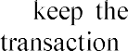
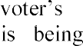
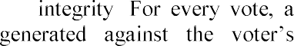
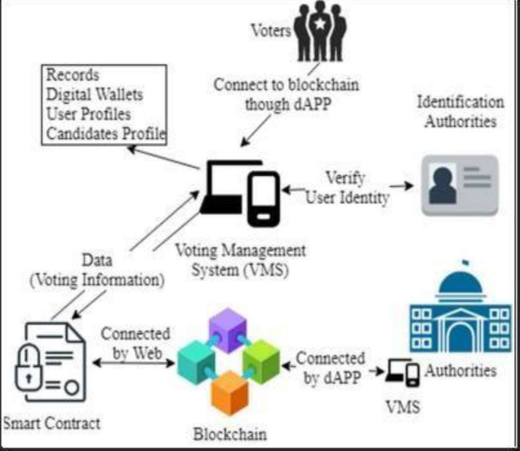




the voter.
request to cast vote, VMS verifies the
voting status of the voter from the blockchain by
checking all transactions hash that already exists against
his/her computerized National ID. If a transaction hash is
found against the
computerized National ID then
VMS declined the request and logout the voter from the
system. If a voter has not voted yet, the request is
transferred to the miner to add the node. The voter selects
the desired candidate and casts his vote. The transaction
is monitored with the help of a transaction hash and
carried out by the miner. The node is then added to the
chain for balloting.Voters must have access to any
smartphone or web browser to take part in voting. The
interface would be provided in multi- languages
to make it easy to use for all users. The proposed system
can contain a large number of voters at the time of
a cryptographic hash. Each vote cast adds a new block in
the chain. System also make sure that only one vote can
be cast by one user by using the vote coin. Even if due to
some technical fault, the balance of the voting coin does
not get updated, hence system ensures that no double
votes have casted by a voter. By checking whether a
transaction hash is generated against voter
National ID or not, if any node or request of a voter is
malicious then miner automatically rejects it. When the
transaction completes and a node is successfully added to
Vote Chain, the voter of that particular voting transaction
is notified through an SMS to his registered phone-no and
email. The voter has provided with a unique transaction
hash by which he can verify his vote through a web portal
and upon successfully completion of transaction the vote
has been counted in the whole voting activity. The voter
wallet has then contained zero vote coins, when a voter
successfully casts the vote.
C. LAYERED STRUCTURE OF THE PROPOSED
VMS.
The proposed framework has ben presented in a layered
System services have been bifurcated the
process into five layers, it has the following layers
presented as shown in Fig. 3. The interface layer contains
all the dAAPs developed for voters and administration.
These are the distribute APPs through which any
stakeholder can connect to VMS. The goal of this layer is
to provide an interface for interacting with the system.
Application Layer provides a user verification system
by involving external sources. It is the front-end interface
of the whole voting system. It encapsulates the data of the
voting system in online databases. All the blockchain
transactions are also handled in this layer. The user is
verified by his/her National ID, that was eligible to take
part in this voting activity.
The Trust layer is the most important part of the whole
framework. It ensures consensus is made correctly and the
data is transferred securely through smart contracts. It
verifies every new block added to the chain.
The basic information related to the blockchain is
stored in the blockchain layer; it keeps track of any faulty
node in the chain to ensure the immutability of the chain.
All the public and private keys, and transaction data are
stored in this layer.
B. WORKFLOW OF PROPOSED MODEL.
The voter after completing the verification is registered
into the Voting Management System. A single chain
system is implemented on the blockchain. The national
database of the country is also integrated with the system
National ID. The transaction is then mined by the minors
and saved in the blockchain. When the voter casts the
vote, his Vote Coin in his/her wallet is also being utilized.
The voter cannot cast another vote after one vote coin is
utilized. As the voter will sign-in through his/her
credentials then the voter has been redirected to the
election interface where all the candidates who are
contesting in his constituency are shown to
Page 7 of 14 - Integrity Submission
FIGURE 2. Voting system architecture

Page 7 of 14 - Integrity Submission
1
4
structure.

Submission ID trn:oid:::3618:89237131
computerized

2

Submission ID trn:oid:::3618:89237131
voting. A decentralized blockchain system enables a
voter to vote from any part of the world. A person can
take part in voting from anywhere, even if he is in a
foreign country, in this way his/her computerized
National ID is verified from the national database so he
can cast the vote.
Voting transactions are sent to a pool from which
miners analyze them and remove the malicious request
by taking the consensus from the other nodes before
adding it to the chain. The votes are fully secured using

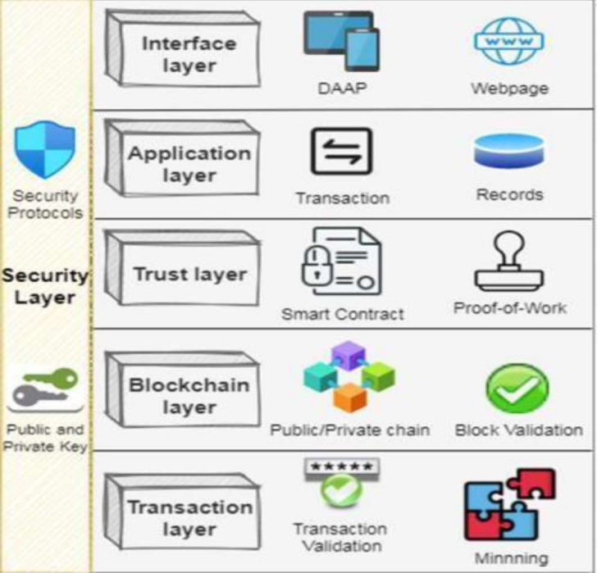


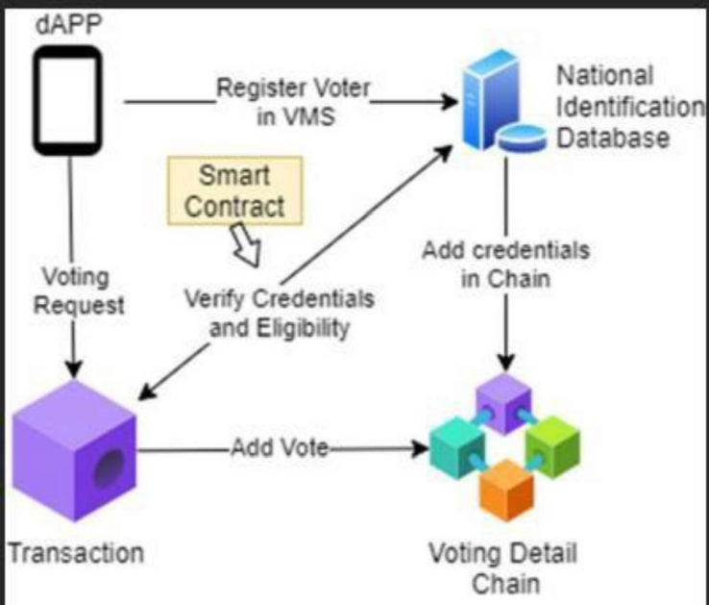

FIGURE 3. Layered structure of the framework.
The transaction layer encompasses all the transactions
that are made by using smart contracts between VMS and
voters. Mining of all the transactions takes place in the
transaction layer.
The most critical layer is the security layer by which
the blockchain is protected from any attack. Any attempt
of attack is defended by using algorithms and basic rules
that make it difficult for external entities to harm the
chain. The security protocols are implemented on the
entire chain. The private and public keys make data
encrypted and secure throughout the system.
D. FLEXIBLE CONSENSUS ALGORITHM.
The proposed framework supports scalable blockchain.
The system provides the support of plug-and-play
consensus algo-rithms. By default, the Proof of Work
consensus (PoW) algorithm has been proposed to keep the
blockchain efficient throughout the voting activity, but
the framework also
other available consensus
algorithms that can be chosen at the deployment time of
the blockchain. Proof of Work states that a certain amount
of computational power has been spent on a transaction.
The framework is flexible enough to incorporate the
change in consensus algorithms at run time. It not only
helps to keep the blockchain secure but also keeps the
voting activity undisrupted.
Choosing
suitable consensus algorithm at
deployment time helps the blockchain to give maximum
performance at run time. Different consensus algorithms
can be implemented in Voting such as Ripple, Proof of
Vote, Proof of Trust, and Proof of Stake. Here, Proof of
Stake tells the computing power required to the system by
validating random nodes. If a node is validating a false
transaction, then it immediately loses its stake in the
voting chain. The transaction from such nodes is not
accepted.
he still has a vote coin, the system allows him to cast vote.
After verifying the voting details i.e. voter identifier, vote,
and timestamp was stored in the chain which saves vote
details. The whole process is elaborated in Fig. 4.
FIGURE 4. Smart contract used in the proposed VMS.
A. dAPP SETUP
Voting Management System consists of different
discussed in this section. It has a user interface
for secure interaction of voters with the system, which also
includes front-end security. A dAPP interface has been
front end of the VMS. The dAPP is a
decentralized application based on blockchain technology.
It runs on a P2P blockchain network. The
identification is critical because the user enters his/her
credentials on that interface, so it should be tamper-free and
simple. The system provides full fair access to every voter
and provides traceability after casting the vote. The voter
login the system by his/her
System uses the ID
details of the user and verify them with the Database to
register the user in the system.
The user gets a unique OTP to log in to the system. The
OTP has generated each time the voter login into VMS. The
purpose of using the dAPP system is to ensure the
Voting
Management System consists of different components
discussed in this section. It has a user interface for secure
interaction of voters with the system, which also includes
front-end security.
Page 8 of 14 - Integrity Submission
Page 8 of 14 - Integrity Submission
components
implemented
use
Submission ID trn:oid:::3618:89237131
credentials.
1

Submission ID trn:oid:::3618:89237131
IV. DESIGN AND IMPLEMENTATION.
The process of voting is run by maintaining our system that
is backed up by the blockchain. The hashes of transaction
for every voter has stored on the chain and all the results
of the election are also stored on the blockchain and from
there the result of the election can be viewed on the
resulting dashboard of the users. The system first verifies
whether the voter is the country nationality holder and it
also checks whether the voter has already voted or not if

4

supports
a

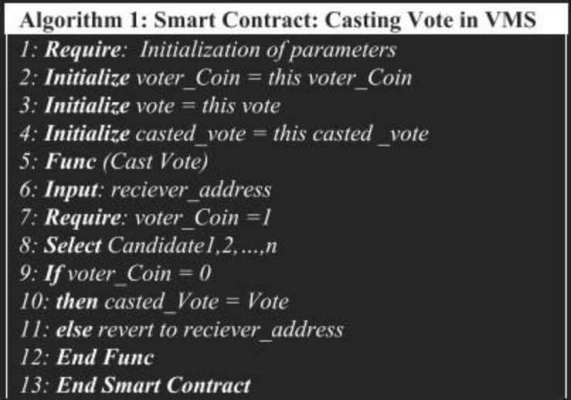



reliability of VMS; as decentralization makes processing
efficient at all nodes. If one node of the system during the
voting system gets vulnerable, all the other nodes are not
harmed. The node which gets vulnerable is reinstate by
other nodes.
B. UNIQUENESS OF VOTERS
The uniqueness of users can be established by using their
computerized National ID. When voters enter their
details, those are then verified with the assistance of
identity is not being used by another voter.
By taking credentials, the
verify, if the person
is eligible to cast a vote in the election or not and whether
any transaction hash has already been assigned to his/her
National ID. If voter is eligible, the system registers the
voter and one Voting Coin is awarded to every voter
wallet. Verifying the user by this method also enables the
system to judge user either fulfills the
imposed by the law and cast the vote. When the voter casts
the vote, a transaction hash is assigned against the National
ID of the voter. Furthermore, the wallet balance of voters
is also updated to zero voting coin, which eliminates the
possibility of doubling a vote from the same user. When a
voter casts a vote, the blockchain updates and saves the
vote of the voter, which means that the user is not be able
to cast a vote again unless a new VC is issued.
C. ELECTION AS A SMART CONTRACT
Smart contracts are providing a secure connection
between the user and the network while executing a
transaction in the chain. These are the rules that are
implemented on the entire blockchain and cannot be
neglected under any condition. All the nodes have to
follow the smart contracts to save the vote in the system
successfully.
The first smart contract is for user verification between
IA and the VMS; it uses the Can-Cast-Vote function
which checks the requirements of the system to make sure
the specified voter can vote. After verification, it enters
the voter details record for further use. The voter is being
connected with a voting smart contract that specifies
which candidates would be shown to him/her. If the
consensus between the node and chain agrees then voting
is allowed. The smart contact to cast vote in the system is
defined in Fig. 5. It checks the Vote Coin in the wallet of
the voter, whether he/she has eligibility
vote or not.
Block 101. In the case of voting for multiple candidates
in an election activity, the data value stores information
about both candidates. The voter is still given only one
vote coin. The voter selects the desired candidates and
uses the vote coin once, which saves information of
multiple candidates in that block.
FIGURE 5. Smart contract casting vote in VMS.
Either the ID would be wrong or the user is not eligible to
cast vote due to any legal reason. Each voter has a wallet
given by the authorities which contains only one Voting
Coin. After a successful transaction, the wallet is reduced
by one and goes empty. It assures that voter is not being
able to vote again. The transaction on the chain is shown
in Table 2. Here the TX Hash is the transaction ID of a
particular transaction, the block in which the transaction is
being performed is under the Block column; it is where the
transaction is sent. The value of the transaction is the
information; to whom the vote was cast. For example,
to cast
Page 9 of 14 - Integrity Submission
Page 9 of 14 - Integrity Submission
2
2
Submission ID trn:oid:::3618:89237131

authorities
requirements

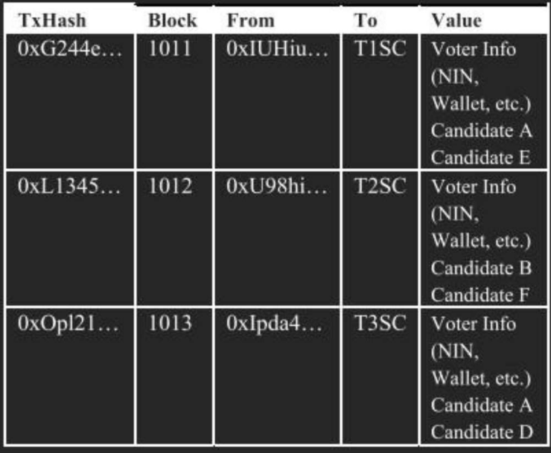

Submission ID trn:oid:::3618:89237131
TABLE 2. Transaction in VMS.
National ID and the wallet address as input and checks if
the user voting coin is available. If the voter has a voting
coin then the smart contract allows them to cast vote
otherwise it has rejected the vote request.
Every vote is stored in the transaction as shown in Table
2 and each voter gets a Transaction ID for his/her vote.
All the information is stored in the transaction is highly
encrypted by using the cryptographic hash. If the
consensus does not match the voter is preceded to a new
screen to help him get the right instructions for voting.
3

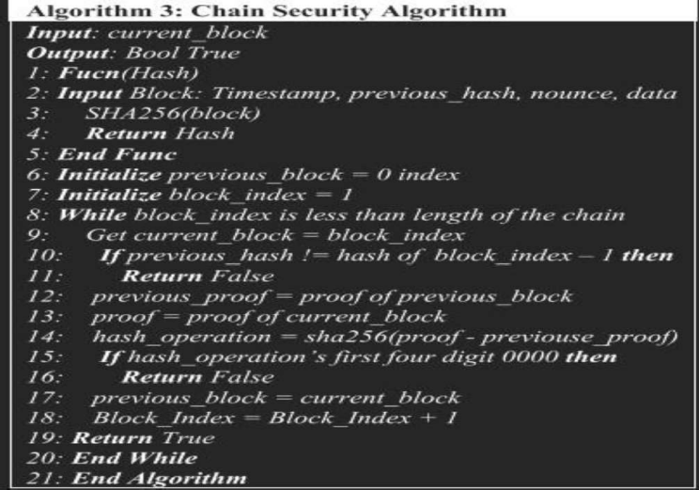
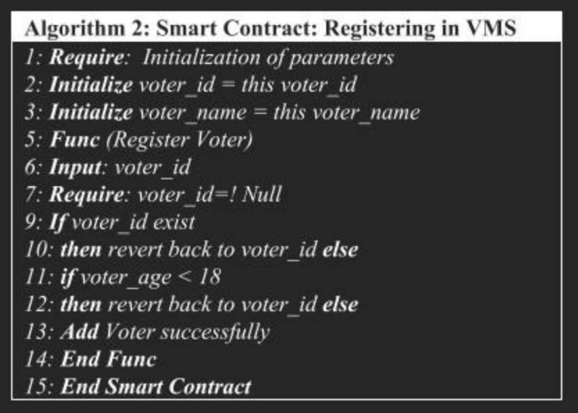




not null, otherwise VMS shows an error and asks to re-
select the candidate. By applying this check in smart
contract, any unnecessary transaction does not carry out
on the blocks of our chain, which contains voting details.
However, no
transaction is carried out by
smart contract. The
is sent to memPool only if
all the conditions come true. A memPool is a replicated
staging area where every node temporarily keeps the
unconfirmed new transactions.
After pushing the transaction to memPool the voter is
notified via his registered phone number. The miner mines
the block of transaction into the blockchain. The system
supports
blockchain and if due to any reason
the transaction is not added to the blockchain, it has rolled
backed to memPool and waiting again for mining process.
System guarantees to commit every transaction from
memPool without voter interaction. The system allows the
miner to mine this rolled back transaction.
In Fig. 6, a smart contract while registering a new
user into the system is presented. This smart contract has
to make sure that a voter never registered in the voting
system twice. For each new registration request, the
system verifies through smart contract that specific voter
should not already exist in chain. If a National ID does not
exist, the system registers the new voter in the system and
adds one voting coin (VC) in his wallet. This smart
contract also verifies the age of the user in another check
so it would not populate the chain with excessive useless
registration. The age is verified with the assistance of
Identification Authorities through his National ID.
FIGURE
FIGURE 8. Chain recovery during partial failure of the
network
(a): Node 2 is disconnected from network, while Node 1 is
mining
normally. (b) Node 2 joins network and replicate the
blocks from Node 1,
as the Node 1 is the longest chain in network.
In case of any technical failure, such as internet breakdown
or power shutdown in an area. The system manages partial
failure of the network as shown in Fig. 8. The affected
Node 2 is unable to continue the mining process due
disconnection from network and during disconnection all
other connected nodes keep mining the blocks as shown in
Fig. 8 a). When the affected Node 2 is connected again
with the network, the longer chain wins as per blockchain
rule i.e. Node 1 is considered the valid chain and replicated
on the affected Node 2.
The function proceeds in case of
6. Smart contract registering in VMS.
The Chain Security Algorithm in Fig. 7 automatically
validates the chain, each time a new block is added. It
verifies the block to be secure and valid before replicating
it to all the peers in the network. The algorithm compares
the hash values of the new and previous blocks. If the
chain is valid then Chain Security Algorithm allows it to
replicate on all nodes in peer to peer network. In case of
malicious activity was detected by the algorithm, it
declares the chain invalid and also informs all peers on
network. This algorithm assures the security of the
blockchain
FIGURE
Chain
c
Page 10 of 14 - Integrity Submission
transaction
incomplete
Page 10 of 14 - Integrity Submission
.
Submission ID trn:oid:::3618:89237131
7.
security algorithm
Submission ID trn:oid:::3618:89237131
1
2
2
1
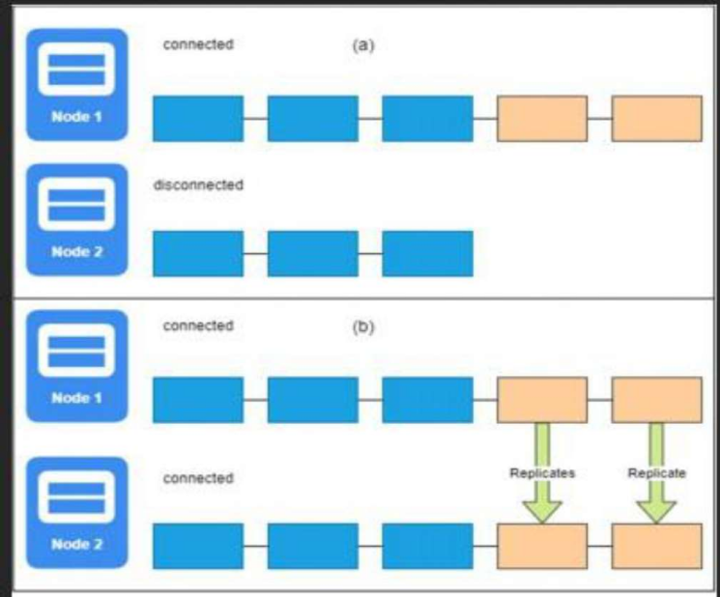
permissioned



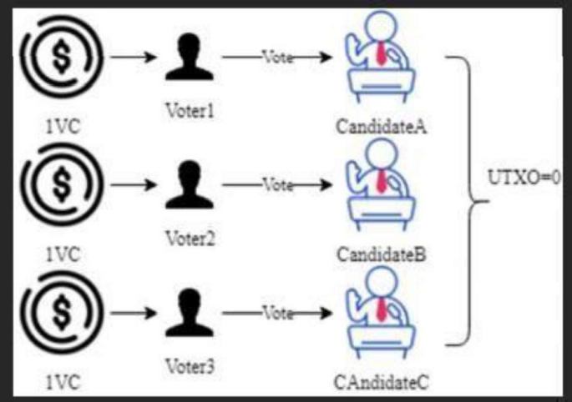
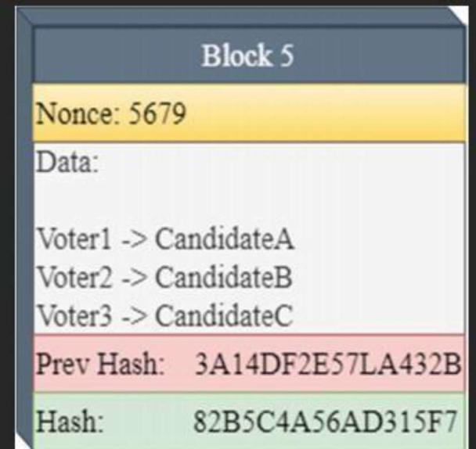

D. TRANSACTIONS IN VMS (UTXO).
This section explains the concept of Unspend Transaction
Outputs (UTXO) in the proposed system. As discussed in
Section IV part c, each voter is given one VC in his wallet
at the time of registering. Voters can spend it only once
while voting for candidates. Voting transactions in VMS
are performed using the UTXO mechanism. In Fig. 9
there are several transactions by different voters to
candidates. While performing each transaction 1 VC is
spent. Miner gets this VC as a reward. There is no
transaction fee in the voting system as system keep the
rights of all voters equal. Voter1 spends 1 VC to cast the
vote for Candidate2. This transaction is recorded and
forwarded to the memPool of transactions. From there,
miners pick up multiple transactions and start to mine.
Here the value of UTXO after each transaction is updated
to zero, ensuring that a voter cannot vote again.
FIGURE 9. Transaction in VMS. (UTXO.)
E. CRYPTOGRAPHIC HASH
Cryptographic hash keeps the data hidden from any
intruder in the system; it has multiple benefits that include
the privacy of the
identity. Cryptographic hash uses
encryption to keep the transaction secure when it is
transmitted on the network to be added to a node, only the
authorized owner of the transaction can decrypt the
transaction and view the content using his private key.
the
the
address of his transaction; as
soon as the vote is cast the voter is notified through SMS
and email. Voters can track their vote in blockchain
through the hash value of the transaction that is provided
on the registered phone number. The voting data includes
all the information saved while casting the vote. The data
remains secured, unharmed, and hidden. The only person
with the tracking information is the voter, who can view
and verify his voting information. The transaction is saved
in a block and locked using the public key of the voter.
While tracking the vote, the node is identified by the
public key. The voter uses his private key to view
the transaction made by his wallet.
Voters can only view the vote; they can never change or
delete the vote once it is cast. Any user information being
transferred in a transaction is encrypted by cryptography.
The process of casting vote in VMS is further elaborated
in Fig. 10. It shows that while casting vote the voter adds
a digital signature to the transaction. This digital signature
keeps the transaction secure.
FIGURE 10. Process of transaction.
A miner in blockchain can only change the nonce value of
the transaction, as all the data is encrypted by using a hash.
Fig. 11 shows an example of a block added to the chain in
VMS. All the voting transactions are placed in chain. The
nonce value is the one that the miner can change, to mine
the block in the chain. All other values are not editable by
a miner. Fig. 11 elaborates the block data in detail but in a
real block, this data is stored in the form of hexadecimal.
The hash value is the tracking address of this block given
to the voter to verify his vote. Miner tries to reach the
golden nonce in order to add the block in chain.
a signature of that voter.
The signature along with the message and public key of
the voter is stored in the vote chain as shown in Fig. 12.
block in
Integrity and confidentiality are key features of
blockchain technology. The system uses signatures to lock
and unlock the messages in the blockchain. Hence, only
the voter is
to view the message. The private
key and message of the user create a signature. A function
called signing algorithm takes the private key and Vote
(message) of the voter to create
Page 11 of 14 - Integrity Submission
providing voter with
Page 11 of 14 - Integrity Submission
FIGURE 11. A
VMS.
Submission ID trn:oid:::3618:89237131
authenticated
Submission ID trn:oid:::3618:89237131
1

1
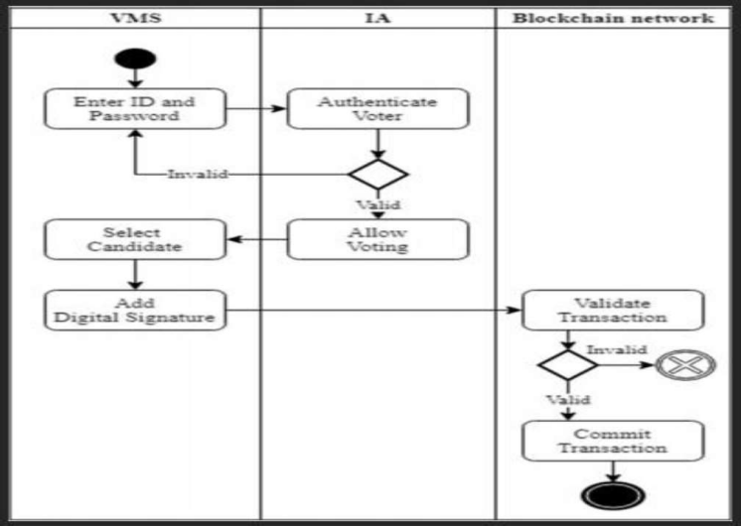


2



1
1

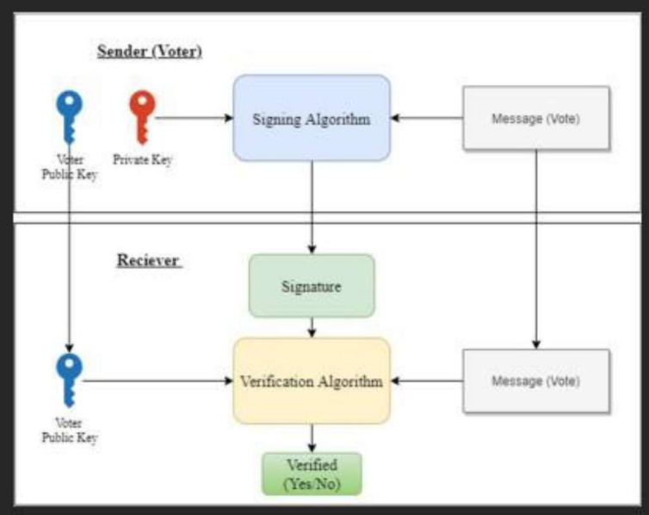


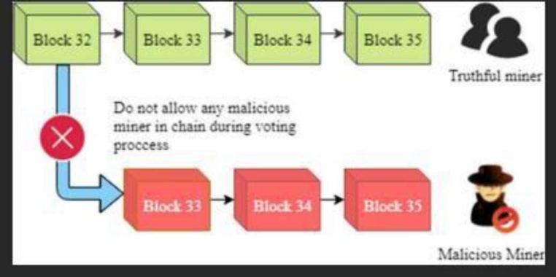

FIGURE 12. Signature.
F. CHAIN DEPLOYMENT
This section elaborates the chain deployment. The voter
casts the vote in the system, the voting transaction is
mined into the blockchain. Each successful transaction in
the blockchain is notified to the voter via registered phone
number. The voter can verify his vote by using the hash
value of the transaction. As this method of changing the
status of vote transactions on chain overcomes the issue
of the partial
transactions, the chain only
computes the voting result by processing the successful
transactions, as only those votes are counted. The delay of
10 minutes has been decided to tackle the transactions
load on blockchain. After voting the election authorities
can view the votes result on the dashboard of the VMS.
The dashboard shows the details of registered voters,
qualified candidates, and election statistics. A flaw of the
system can be the low literacy rate of any country, but it
can be resolved by providing guidelines through media
and by keeping the interface as simple as possible. The
system also defines multi-language interface that can
easily be used by native language voters. The voting
system is secured and the only risk is 51% monopoly of
hash rate by a miner or group of miners of the voting
system.
G. PREVENTING ATTACK 51%
The 51% attack means monopolizing the 51% hash rate
of the blockchain. To achieve such a level of hash rate
very high computational power is required. In VMS 51%
of attack is prevented by two solutions. Firstly, the hash
selected miners leave the mem-pool while voting activity,
the system detects the activity and does not allow those
miners to re-join the chain. To keep it fully secure and
tamper-proof, if any malicious activity occurs or a miner
tries to add a false block in the chain that is not verified, a
51% attack is declared and the process of mining activity
is stopped. Nodes with larger chains win and monopolize
the network. The blockchain is permissioned and nodes
cannot join the network without the permission of the
Election Authority. At the run time a group of malicious
nodes cannot join without verification of credentials and
permission. Hence in proposed solution 51% attack is not
possible.
FIGURE 13. Prevention of 51% attack in VMS.
V. PERFORMANCE EVALUATION
This part contains the performance evaluation of the
Proposed framework; data is taken with real-life scenarios
using Remix a browser-based Blockchain tool. Solidity is
used as the programming language in the experimentation
of the
model.
A. RESPONSE TIME OF VMS
The response time of VMS can be determined by
calculating the time taken to execute each transaction in
the blockchain. Fig. 14 shows the response time of the
system. It shows the increase in response time of the VMS
as the votes are increased. The blockchain is decentralized
hence each node responds according to its commuting
power.
Page 12 of 14 - Integrity Submission
monitored
Page 12 of 14 - Integrity Submission
during

proposed
1
process

Submission ID trn:oid:::3618:89237131

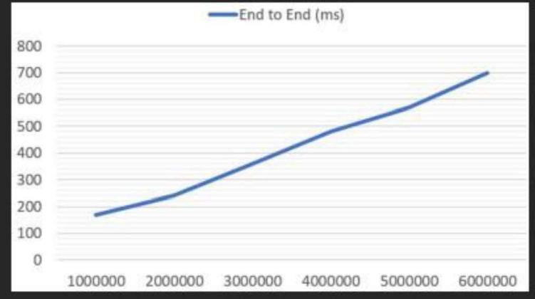

Submission ID trn:oid:::3618:89237131
rate of each miner is pre-recorded in the system. Hash
rates are monitored to check if any miner does not equip
a 51% hash rate in a blockchain system. If such a user is
detected, he is not allowed to mine during the voting
process. Secondly, miners are pre-selected for the voting
process. Miners are hired to mine during the voting
process, under the supervision of authorities. Any external
group of miners is not0 allowed
voting as
elaborated in Fig. 13. The system is being
constantly while voting activity, the network blocks any
malicious miner to mine block in the chain. If pre-
FIGURE 14. Response time of VMS.

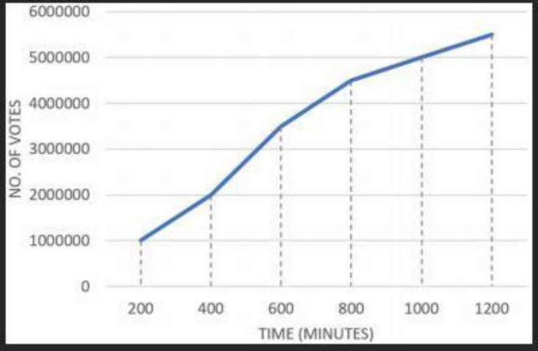


The increasing number of votes in the system shows a
uniform increment in the size of the blockchain. Response
time is increased gradually as more nodes are waiting in
the memPool of miners. Flexible Consensus algorithms
are applied here to keep the efficiency of the chain
uniform.
B. SIZE OF CHAIN
The chain size is around 0.004MB to 0.2MB for every 500
Blocks. The size keeps on increasing with the addition of
Blocks in the chain. In Fig. 15 uniform increment in the
size of the chain is shown as the blocks are being added
over time.
The chain consists of zero blocks at initially, but
eventually, it increases in size because the process of
voting is usually 1-2 days. Hence latency can be an issue
for a very readily growing chain. The size of the chain
increases slowly when the voting process starts; after the
intense voter traffic of transactions in memPool the voters
start to mine the transactions in the blockchain, once the
mining process starts, the size of the chain increases
gradually. After successfully mining all votes in
blockchain the tallying process starts.
C. LATENCY
The latency of the system is analyzed by measuring the
time taken to execute the transaction request. The
transaction request is triggered at a respected time that
gives the latency rate of the system. As shown in Table 3
It may increase by an increase in number. of requests per
second. Tallying of votes is being held on different nodes
of the system during the
process, it makes it very
efficient and reduces any further processing at a singular
node. Intruder nodes are blocked by using smart contract
algorithms, these
VI. CONCLUSION
The purpose of proposing a blockchain-based solution for
the voting system was to build trust between government
and voters to make-believe that their voting integrity
kept
safe. The blockchain-based voting is also make the voting
process transparent and trustworthy. The amount of money
spent on voting activity in any country is very high for the
traditional voting system, whereas the proposed solution
for using the blockchain voting systems to make the voting
process cheaper, faster and trustworthy. It helps to enhance
relations with their democratic state, as they get a
transparent system on which they can rely and trust. The
framework elaborates on the feature, services and role of
official authorities using blockchain in the voting system
which is highly in need to improve the level of the electoral
system and its reliability, traceability and trust. The
of each vote makes it immutable. The use of
hash assures the privacy of voters and the concept of public
and private keys allows the authorities to control the
process precisely. The traceability of the voting system
assists in preventing hackers from modifying or viewing
the voting information. It assures that one voter only votes
one vote. The usability of this system performs well by
using the more effective approach of implementing a
flexible consensus algorithm to reduce extensive
computing resources in the blockchain. This transparent
behavior of the system tends to be promising for voters to
rely and trust. The Chain Security Algorithm is also added,
which automatically verifies the validity of the chain each
time a new block is added to it. Smart Contracts play an
important role to prevent any incomplete and malicious
transactions in the blockchain voting system.
The proposed system is a secure, transparent, and
platform for the authorities, and voters. The
proposed framework has a promising output based on the
performance evaluation of blockchain technology in VMS.
The experiment shows that the system keeps processing
efficiently while processing a large number of transactions
in the blockchain.
transaction to hit the blockchain. The voter is only allowed
to vote when all the relevant smart contracts are fulfilled.
Hence, the traffic on-chain is controlled during the voting
process. Latency in the chain depends on the computing
power of nodes; flexible consensus algorithms keep the
blockchain efficient throughout the voting activity. The
transaction inclusion time in the blockchain is fixed, it
FIGURE 15. Behavior of size of chain.
TABLE 3. Latency in VMS.
Page 13 of 14 - Integrity Submission
Page 13 of 14 - Integrity Submission
I
verification
reliable
Submission ID trn:oid:::3618:89237131

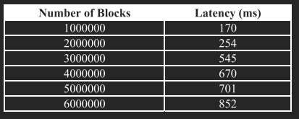
Submission ID trn:oid:::3618:89237131


1


2
voting
algor


2

Page 1R4 Eof F14E- RIntEegNrityCSEubSmission Submission ID trn:oid:::3618:89237131

- S. S. Hossain, S. A. Arani, M. T. Rahman, T. Bhuiyan,
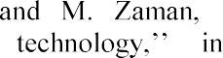
system using
-voting
Blockchain Technol. Appl., Dec. 2019, pp. 113117, doi:10.1145/3376044.3376062.
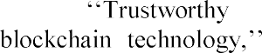
- B. Shahzad and J. Crowcroft, electronic
Access, vol. 7, pp. 2447724488,2019, doi: 10.1109/ACCESS.2019.2895670.

- F. P. Hjálmarsson, G. K. Hreiòarsson, M. Hamdaqa,
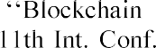
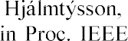
-based E-Voting
(CLOUD), Jul. 2018, pp. 983986.
- M. S. Farooq, M. Khan, and A. Abid, to make charity collection transparent and auditable using
May 2020, Art. no. 106588,
doi:10.1016/j.compeleceng.2020.106588.
- N. M. Crosby, P. Pattanayak, S. Verma, and V. Kalyanaraman, technology Beyond Sutardja Center Entrepreneurship Technol., Univ. California, Berkeley, CA, USA, Tech. Rep., Oct. 2015. Accessed: Jan. 24, 2018. [Online]. Available: http://scet.berkeley.edu/wpcontent/uploads/BlockchainP aper.pdf
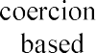
- -free and
universally verifiable blockchain-
Comput. Netw., vol. 174, Jun. 2020, Art. no. 107234, doi: 10.1016/j.comnet.2020.107234.

- S. Shah, Q. Kanchwala, and H. Mi. (2016). Block Chain Voting System. Economist. [Online]. Available: https://www.economist.com/sites/default/files/northeaste rn.pdf
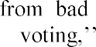
- S. Park, M. Specter, N. Narula, and R. L. Rivest, blockchain J. Cybersecurity, vol. 7, no. 1, pp. 1
15, Feb. 2021, doi: 10.1093/cybsec/tyaa025.
- A. Barnes, C. Brake, and T. Perry. Digital Voting with the use of Blockchain Technology Team Plymouth Pioneers-Plymouth University. Accessed: Feb. 14, 2022. [Online].Available:https://www.economist.com/sites/defa ult/files/plymouth.pdf
- J. Huang, D. He, M. S. Obaidat, P. Vijayakumar, M. Luo, and K.-K.-

ACM Comput. Surv., vol. 54, no. 3, pp. 128, Apr. 2022, doi: 10.1145/3439725.
- F. Fusco, M. I. Lunesu, F. E. Pani, and A. Pinna, -voting, a blockchain based e- Proc. 10th Int. Joint Conf. Knowl. Discovery, Knowl. Eng.Knowl. Manage., 2018, pp. 223227, doi: 10.5220/0006962102230227.
- G. Rathee, R. Iqbal, O. Waqar, and A. K. Bashir,
the design and implementation of a blockchain enabled E- Voting application within IoT-
IEEE Access, vol. 9, pp. 3416534176, 2021, doi:10.1109/ACCESS.2021.3061411.

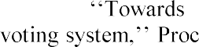
- M. Pawlak, A. Poniszewska- nd N. Kryvinska, the intelligent agents for blockchain e-
246, Jan. 2018, doi: 10.1016/j.procs.2018.
10.177.
- D. Chaum, A. Essex, R. Carback, J. Clark, S. Popoveniuc, A. Sherman, and P. Vora, -voting 40 scantegrity: End-to-end voter-verifiable optical-scan Secur. Privacy, vol. 6, no. 3, pp. 4046,
May 2008. Accessed: Feb. 14, 2021. [Online]. Available: https://www.computer.org/security/

- ​
contract for boardroom voting with maximum voter

Sliema, Malta: Springer, 2017, pp. 357375, doi: 10.1007/78-3-39-7097-7_20.

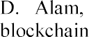


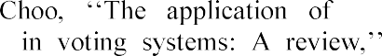

[9]
Int. J. Electron. Government Res.,vol. 14, no. 1, pp. 53 62, Jan. 2018, doi: 10.4018/IJEGR.2018010103.
[10] C.
2nd World Conf. Smart Trends Syst., Secur. Sustainability (WorldS), Oct. 2018, pp. 2227, doi: 10.1109/WorldS4.2018.8611593.
Page 14 of 14 - Integrity Submission Submission ID trn:oid:::3618:89237131

